

**Bachelor of Science in Computing**

**School of Public Administration**

**Macao Polytechnic Institute**

**COMP 492 Final Year Project**

**Project Proposal**

|  |  |
| --- | --- |
| **Indoor Robot Helper** | |
|  |  |
| Project Number: | 29 |
| Student Name: | Key, Liang Yijuan |
|  |  |
| Supervisor: | Dr. Cora Lai |
| Assessor: | Dr. CT Lam |
|  |  |
| Submission Date: | 2014/09/11 |

Contents

1. Main tasks and Objectives 3

2. Project Description 3

3. Summary of Related Work and Key References 4

4. Project Workplan 4

5. Risk Assessment 5

6. Reference 6

# **1. Main tasks and Objectives**

The main task of this project is to develop an indoor navigate robot which can go to different places and do the delivery automatically as a helper. This robot can move follows the color line and fetch objects and do delivery. LEGO® MINDSTORMS® EV3 is chosen as model.

The following functions should be developed with the robot in this project:

* Move from starting position to different destinations
* Move according color lines
* Turn left or right correctly
* Go back to start area after reach the destination
* Read NFC tags to recognize places
* Fetch objects

# **2. Project Description**

In this project the following points should be done before 28 April, 2015

* Study related works
* Experiment how to place the different sensors
* Experiment how to place NFC tags
* Experiment fetch different objects
* Design fuzzy logic for movement
* Recognize different color and run action correctly
* Develop a moving road database
* Design the program
* Implement the program
* Writing the report

The following table shows scopes in this project:

|  |  |
| --- | --- |
| Function Provided | My project |
| Color senor | **√** |
| NFC | **√** |
| Move follows the line | **√** |
| Fetch objects | **√** |
| Deliver objects | **√** |
| Move in a room | **√** |
| Move in the same floor | **×** |
| Move in different floor  **Figure 1 Project scope** | **×** |

As limitation of Bluetooth signal range, in this project the robot will not move around the whole floor. Instead it will move in A322 in MPI. In the very begin, this EV3 robot will move in a whiteboard. Color lines will be drawn with highlight pens.

# **3. Summary of Related Work and Key References**

As the development of technology, human interactive robot development has been a big topic in the world. Developing a robot helper instead of human do by themselves has been a trend of people’s interests. Fuzzy logic [1] design, which is introduced in 1960s, will be also used as other similar robot projects. LEGO® MINDSTORMS® EV3 programmable robot is chosen for this project because it is small enough to move and carry. Also, spare parts are available to be used to develop extra original modules too. And this EV3 robot also supports different kinds of connection means including Wi-Fi (but this requires an added Wi-Fi adaptor). Therefore, it is well famous to be selected in similar kinds of projects.

# **4. Project Workplan**

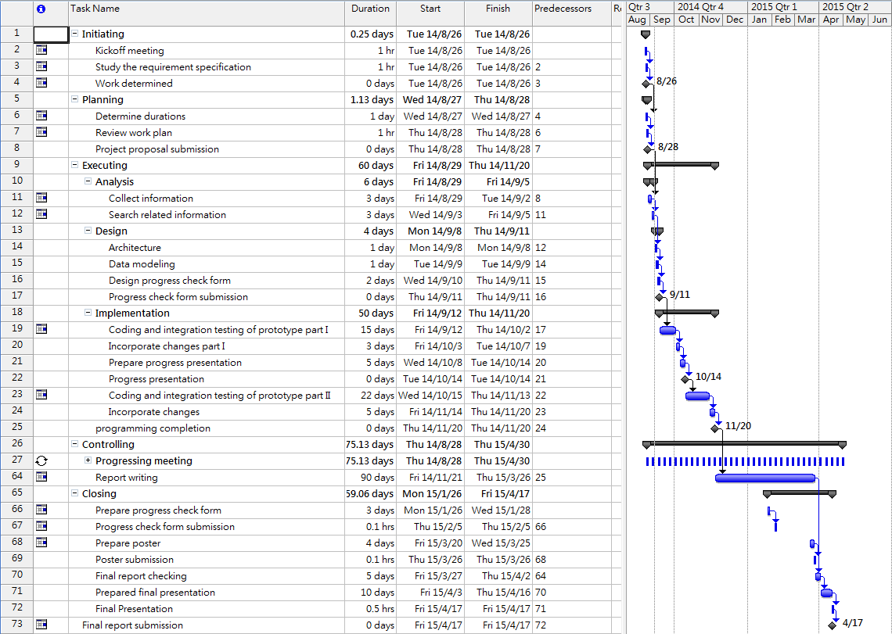The schedule of all the works are shown in Figure 2

**Figure 2 Work plan**

# **5. Risk Assessment**

During the process of the project risks may occurs as follows:

* Battery runs out
  + There will have a risk that battery runs out during the project which will lead the robot cannot move properly. Also, as movement control is designed to use set power volume if battery cannot provide enough power the move distance may be affected. Moreover, full-charged backup batteries are prepared.
* Connection is disabled
  + As there is too many radio signals in the campus, Bluetooth connection may be interfered. This may cause cannot set up connection between the computer and the robot. If this situation happens, it is considered to move to another place, for example the rooftop, to set up connection. As the rooftop is in the top of the teaching building, there is less interferes. And the connection set up process can be done. Since once the connection is set up it will not disconnect until disconnect is operated, after set up connection, everything can be move back to the lab and continue the rest of the project.
* Hard disk damage and data lost
  + All the develop programs or documents may lost due to hard disk problem. Therefore, besides saving data in the local computer, at least one copy backup will be place in a USB and a backup copy will be put in the network. Once developed data is lost, backup data will use to continue the project. Furthermore, all the updates will be done on a new copy of the previous version so that once update is incorrect, the older version can be found immediately.
* Motor out of function
  + In case of accident, motor of the robot may be out of function. This may lead to the robot cannot move. If this happen, replace motor needs to be brought.

You are to determine (either quantitatively or qualitatively) the risks related to a concrete situation and a recognized threat to your project. Contingency plans should also be stated.

This section describes the key risks of your project. For example, if you work on a web crawler project in a specific website, there are possibilities that the crawler is forbidden by the website when they discover your intention. If you work on a hardware-related project, there are possibilities that the hardware cannot be delivered on time. Such kind of threats that potentially delay or even fail your project should be pre-cautioned and stated here.

# **6. Reference**

[1] Wikipedia, <http://en.wikipedia.org/wiki/Fuzzy_logic>, [Sept 09, 2014]